Develop a VB Project to design a notepad using common dialog box

Form design
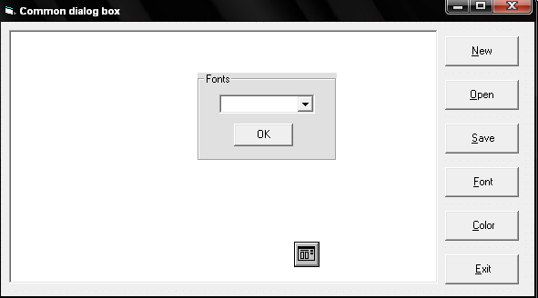

Properties:

Controls | Name | Caption
Richtextbox | Rt
Commondialogbox | Cd
Frame1 | Frame1
Combo1 | Cofont
Command1 | Cmdnew | New
Command2 | Cmdopen | Open
Command3 | Cmdsave | Save
Command4 | Cmdfont | Font
Command5 | Cmdcolor | Color
Command6 | Cmdexit | Exit
Command7 | Cmdok | OK

8.Common Dialog Box
Aim:
To develop a VB Project to design a notepad using common dialog box

Coding:
Private Sub cofont_Click()
rt.SelFontName = cofont.Text
End Sub

Private Sub Cmdnew_Click()
rt.Text = " "
rt.SetFocus
End Sub

Private Sub Cmdopen_Click()
Dim s As String
cd.ShowOpen
s = cd.FileName
rt.LoadFile (s)
rt.SetFocus
End Sub

Private Sub Cmdsave_Click()
cd.ShowSave
s = cd.FileName
rt.SaveFile (s)
rt.SetFocus
End Sub

Private Sub Cmdfont_Click()
cofont.Visible = True
Frame1.Visible = True
Cmdok.Visible = True
End Sub

Private Sub Cmdcolor_Click()
cd.ShowColor
rt.SelColor = cd.Color
rt.SetFocus
End Sub

Private Sub Cmdexit_Click()
End
End Sub

Private Sub Cmdok_Click()
Frame1.Visible = False
cofont.Visible = False
Cmdok.Visible = False
End Sub

Private Sub Form_Load()
Dim i as Integer
For i = 1 To Screen.FontCount-1
cofont.AddItem Screen.Fonts(i)
Next i
Frame1.Visible = False
cofont.Visible = False
Cmdok.Visible = False
End Sub

Output:

